The Economic Influence of Billionaires

**Charlie Doubet & Matthew Riedl**

1. **Introduction:**

Money is often a symbol of power, but does it also reflect influence and shape economic structure? Who are the top ten billionaires in terms of wealth? What countries do these billionaires reside in and what industry did they obtain their wealth in? Does the number of billionaires reflect stability or volatility in a country's GDP? How does the number of billionaires affect a country’s unemployment rate? Specifically, do many billionaires reflect a stable economy with low unemployment or does it reflect high unemployment due to concentration of wealth?

In this project, we plan to analyze whether the number of billionaires in a country correlates/affects real-world economic standards. We will be joining datasets to explore how individual wealth may impact a country's economy.

1. **Data:**

For our project, we plan to use three datasets that will allow us to analyze the correlation between billionaires, GDP growth, and unemployment rates across each country. The data sources are below:

**2.1** **The Complete World Billionaire List**

**Source:** [Kaggle](https://www.kaggle.com/datasets/guillemservera/forbes-billionaires-1997-2023)

Our first dataset from Kaggle gave us every billionaire per year since 1997. In addition, the dataset includes details like rank, net worth, industry, and country. This CSV file will be cleaned to build a year-by-year profile of billionaires globally from the past 5 years. We will then use the cleaned data in our data analysis to attempt to answer our hypothesized questions.

**2.2** **Real GDP Growth Per Country**

**Source:** [MacroTrends](https://www.macrotrends.net/global-metrics/countries/ranking/gdp-growth-rate)

Our second dataset is from MacroTrends and provides us with the annual GDP growth rate for each country over the past 5 years. The data has six columns for Country Name and the five years we are looking for (2023, 2022, 2021, 2020, and 2019). This data will be scraped using the Selenium and WebDriver package within Jupyter Notebook and loaded into a DataFrame with each country's GDP change from year to year.

**2.3** **Unemployment Rates Per Country**

**Source:** [**World Bank**](https://data.worldbank.org/indicator/SL.UEM.TOTL.ZS)

The third source is from the World Bank Group and provides us with unemployment rates for each country. The dataset is already in a CSV file which will make it compatible with the other two datasets. We will also use the past 5 years for unemployment rates. We plan to intersect all three of our datasets to determine the impact on billionaires, GDP per country, and unemployment rates.

**2.4** **Merged Dataset: Billionaires and Countries GDP Growth Rates**

We merged our billionaires and GDP growth rates dataset to analyze whether countries with several billionaires have an impact on the GDP within their country. We merged the two datasets through a left join on country_of_residence from the Billionaires dataset and right on ‘Country’ from GDP. We also renamed all of the year columns within the merged dataset to ensure clarity on each year GDP change.

**2.5** **Merged Dataset: Billionaires and Countries Unemployment Rates**

We did a very similar merge to create this dataset for analysis on Billionaires' impact on unemployment rates within their country. We merged the two datasets through a left join on country_of_residence from the Billionaires dataset and right on ‘Country Name’ from unemployment rates. We also renamed all year columns to ensure clarity of each year's unemployment rates.

**Data Dictionary**

|  |  |  |  |
| --- | --- | --- | --- |
| Field | Type | Source | Description |
| year | Text | All | Year of the billionaire, GDP, and unemployment |
| name | Text | Kaggle | Name of the Billionaire |
| net_worth | Numeric | Kaggle | Net worth of the Billionaire |
| industry | Text | Kaggle | Industry the Billionaire obtained their wealth |
| country | Text | All | Country where Billionaire resides, applicable GDP growth rate for the country, applicable Unemployment rate for the country |
| gdp_growth | Numeric (%) | MacroTrends | GDP year by year growth rate per country |
| Unemployment_rate | Numeric (%) | World Bank | Year by Year Unemployment rate per country |

1. **Analysis**

**3.1** **Billionaire Statistics**

We wanted to first find the top ten billionaires in the world, the country they reside in, and the industry in which they obtained their wealth. We did this to get a brief overview of our data before we began to dive deeper into our analysis. By doing so, we know which countries could be key to monitor as we look more into how billionaires impact the other variables we are analyzing. We created three graphs to answer these questions. Figure 1 is a bar chart showing the name and net worth of the top ten billionaires currently in the world. Figure 2 is a pie chart showing the country of residence for these top ten billionaires. In Figure 3, we have a bar chart showing the industry where these billionaires made their money.

The major takeaway from these three charts is the Figure 2 pie chart, which shows the country of residence. Since our analysis is on a country basis, this is an important chart to remember as we begin to answer and analyze our datasets. Seventy percent (7/10) of the top ten reside in America, followed by 10% (1/10) in France, Mexico, and India. Based on this, we can assume these countries will be pivotal to identify when answering our next questions. America having 7 of the top 10 means it will be a major player, and for France, Mexico, and India, we can assume that having one billionaire in the top ten most likely means there are other billionaires in the country based on government standards.

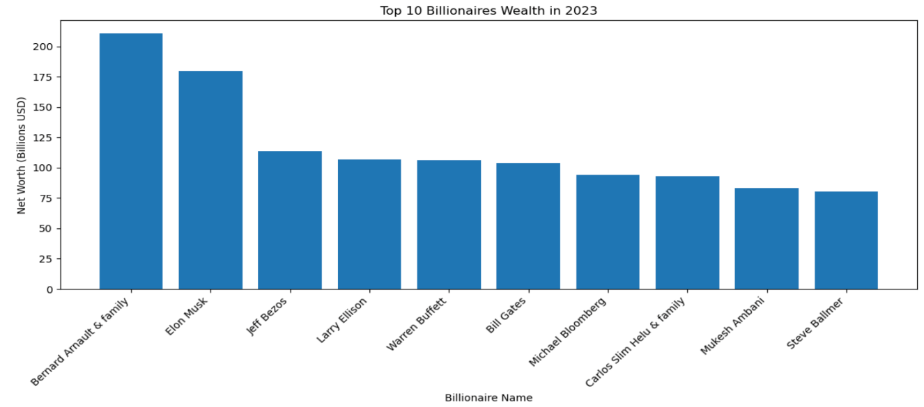

Figure 1: Top 10 Billionaires by Net Worth

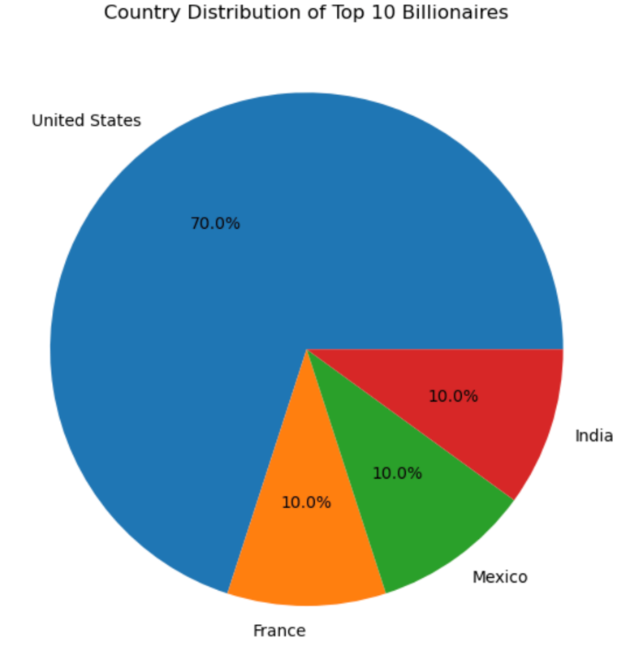

Figure 2: Country Distribution of Top 10

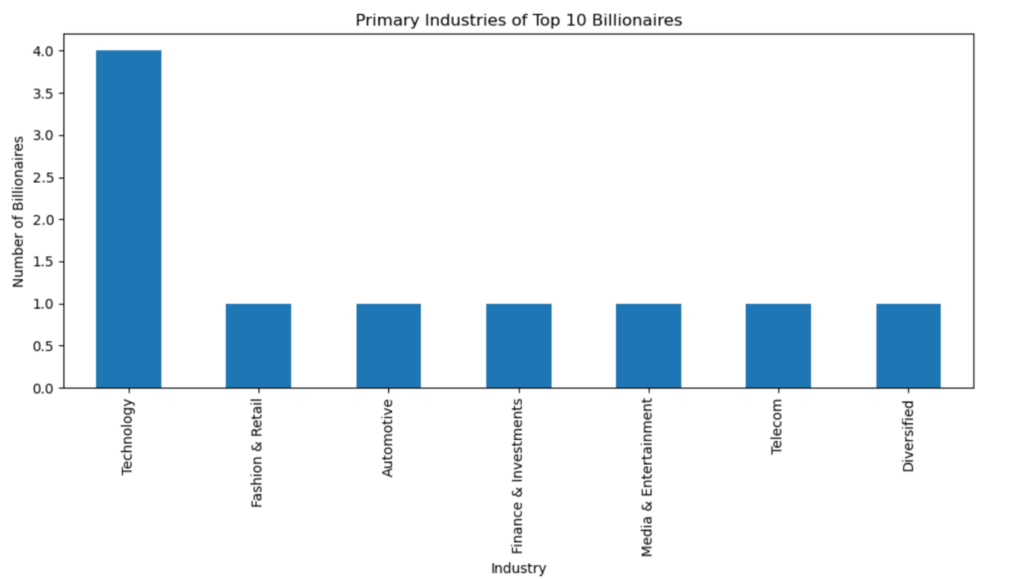Figure 3: Industry Distribution of Top 10 Billionaires

**3.2** **Countries' GDP Change in Relation to Billionaire Count**

To find out if the number of billionaires per country influences their GDP change, we merged the billionaire’s dataset with the GDP change dataset. We first calculated the billionaire count per country and the average GDP change for each country using the mean function. By doing this, we were able to compute the correlation between the two features.

Figure 1 places a dot where the country lies based on the number of billionaires being the X-axis and average GDP change being the Y-axis. A higher placement on the Y-axis reflects a positive average GDP change, reflecting a strong economy. The top 5 countries in terms of billionaire count have labels on the graph, and we can see that they all have positive average GDP changes. It would appear the average GDP change across all our data ranges between 0-2%. Three of our top 5 countries in terms of billionaire count beat this average.

We did further analysis, shown in Figure 2, to find the correlation between billionaire count and average GDP change. Using our data, we were able to conclude a 0.088 correlation between billionaire count and GDP change, thus implying that for countries with a higher number of billionaires, the average yearly change in GDP is higher. We believe this correlation to be a strong reflection of the data because it gives us a numerical value to answer our question on whether an increasing number of billionaires affects GDP in a country.

In Figure 3, we have a table listed by country showing their corresponding number of billionaires and average yearly GDP change. The chart shows what is being displayed in Figure 1 with numerical values. Analyzing the chart, we can see the highest % changes in the GDP change column are towards the top. This chart is a good addition to our plot in Figure 1 because it lists the top 20 countries in terms of billionaire count. This excludes all countries that have a low count of billionaires, which is a driving point in our project. These countries with low billionaires also may have younger growing economies, which explains why some of the data points in Figure 1 seem a bit extreme. It’s hard to imagine an average GDP growth rate of 6% and above is sustainable, but these countries are not listed on our chart.

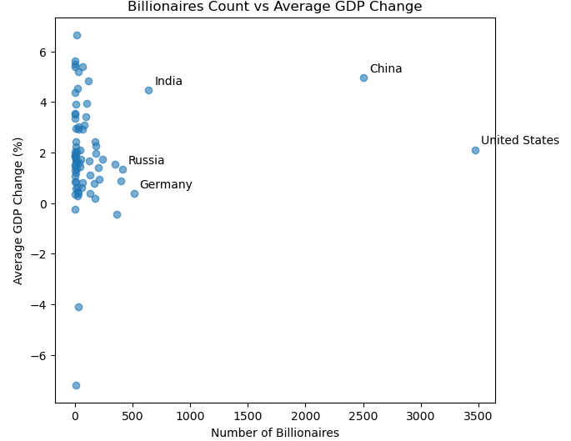Figure 1: Billionaire Count vs Average GDP Change

|  |  |
| --- | --- |
| **Metric** | **Value** |
| Correlation between Billionaire Count and GDP Volatility | 0.08773964971000325 |

Figure 2: Correlation Statistic

|  |  |  |
| --- | --- | --- |
| **Country of Residence** | **Billionaire Count** | **Average GDP Change** |
| United States | 3472 | 2.108 |
| China | 2502 | 4.966 |
| India | 641 | 4.47 |
| Germany | 514 | 0.384 |
| Russia | 415 | 1.338 |
| United Kingdom | 402 | 0.88 |
| Hong Kong | 364 | -0.444 |
| Switzerland | 350 | 1.536 |
| Brazil | 244 | 1.726 |
| Italy | 210 | 0.946 |
| Canada | 205 | 1.41 |
| Taiwan | 193 | NaN |
| South Korea | 186 | 1.96 |
| Australia | 183 | 2.25 |
| Japan | 178 | 0.176 |
| Singapore | 175 | 2.418 |
| France | 170 | 0.778 |
| Spain | 131 | 1.096 |
| Thailand | 131 | 0.394 |
| Sweden | 127 | 1.686 |

Figure 3: Billionaire Count and Average GDP Change Table

**3.3** **Unemployment Rates in Correlation to Billionaire Count**

To find if there is a correlation between a country's unemployment rate and the billionaire count, we merged those two datasets (unemployment and billionaire). We first calculated the billionaire count and the average unemployment rate from the past five years. We were able to create a scatter plot to show the correlation between these two features.

In Figure 1, we have a plot displaying countries' billionaire counts and corresponding unemployment rates. The average unemployment rate is reflected on the Y-axis, so the lower a country is on the plot, the better their economy/unemployment rate is. We can see in this figure that the four highest countries in terms of billionaire count all have low corresponding average unemployment rates, all around the 5% range. Countries along the Y-axis, symbolizing little to no billionaires, have unemployment rates that range from 0-15%.

In Figure 2, like our analysis in 3.2, we looked at the correlation statistic between billionaire count and unemployment rate. We found the correlation to be –0.09, meaning that for countries with more billionaires, their average unemployment rate is typically lower. This negative correlation tells us that more billionaires in a country symbolize a stronger economy with lower unemployment rates.

Figure 3 displays our top 20 countries in terms of billionaire count. It also shows their billionaire count as well as average unemployment rate in numerical value. It is a numerical visual of our Figure 1 plot and further explores our data. We can see that the numbers in average unemployment rate begin to increase as we move down our chart, indicating the negative correlation and symbolizing the stronger economies having more billionaires.

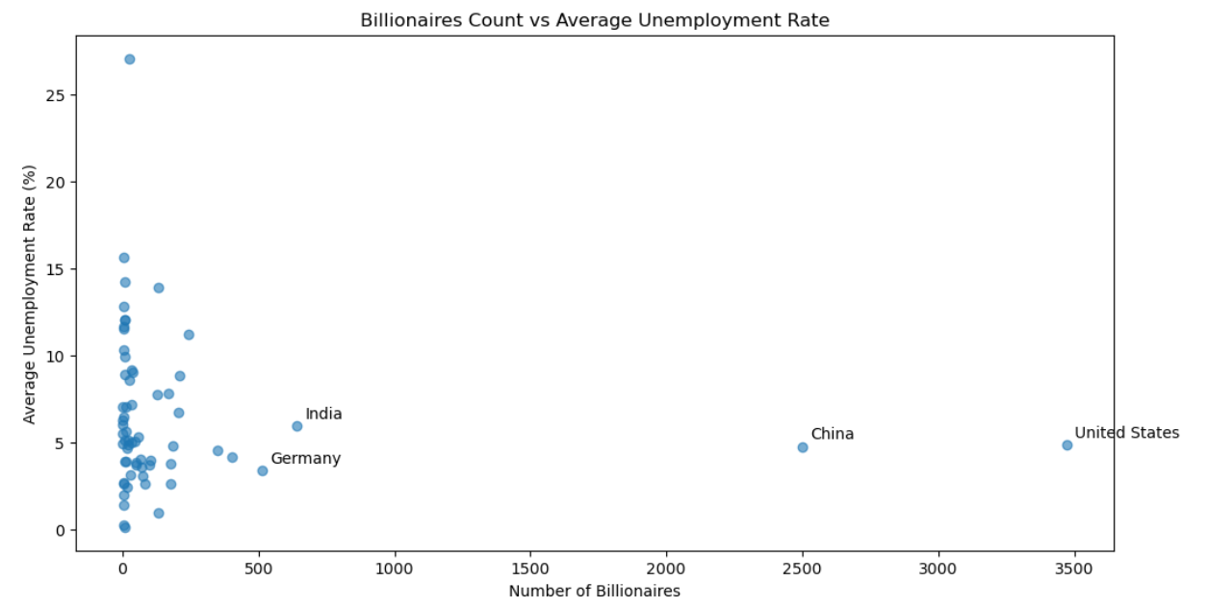Figure 1: Billionaire Count vs Average Unemployment Rate

|  |  |
| --- | --- |
| **Metric** | **Value** |
| Correlation between Billionaire Count and Unemployment Rate | -0.090027901 |

Figure 2: Correlation Statistic

|  |  |  |
| --- | --- | --- |
| **Country** | **Billionaire Count** | **Average Unemployment Rate** |
| United States | 3472 | 4.8696 |
| China | 2502 | 4.752 |
| India | 641 | 5.9486 |
| Germany | 514 | 3.362 |
| Russia | 415 | NaN |
| United Kingdom | 402 | 4.164 |
| Hong Kong | 364 | NaN |
| Switzerland | 350 | 4.5316 |
| Brazil | 244 | 11.1946 |
| Italy | 210 | 8.86 |
| Canada | 205 | 6.704 |
| Taiwan | 193 | NaN |
| South Korea | 186 | NaN |
| Australia | 183 | 4.8198 |
| Japan | 178 | 2.6326 |
| Singapore | 175 | 3.7806 |
| France | 170 | 7.786 |
| Spain | 131 | 13.8956 |
| Thailand | 131 | 0.9766 |
| Sweden | 127 | 7.765 |

Figure 3: Billionaire Count and Avg Unemployment Rate Table

1. **Conclusion:**

In this project we analyzed billionaires and how they contribute to a country's economy. By combining information about billionaires along with GDP change and unemployment rates we came to the following conclusions about billionaire influence.

* 1. *Who are the top ten Billionaires in terms of wealth? What countries do they reside in? What industries did these billionaires obtain their wealth in?*

The current top 10 billionaires in terms of wealth are Bernard Arnault, Elon Musk, Jeff Bezos, Larry Ellison, Warren Buffet, Bill Gates, Michael Bloomberg, Carlos Slim Helu, Mukesh Ambani and Steve Balmer. Seven of them reside in the United States and the rest are from France, Mexico, and India.

* 1. *Do a lot of Billionaires symbolize a stable economy and lead to steady GDP for a country? Does few Billionaires symbol volatile GDP?*

Average GDP change in countries with a lot of billionaires typically show steady growth while countries with little to no billionaires range from negative GDP change to very high GDP change. With a positive .088 correlation, we can conclude that more billionaires can be a symbol of a stable established economy that experiences steady GDP growth.

* 1. *Do countries with a lot of billionaires have low unemployment rates signaling healthy economies? Or do countries with a lot of billionaires have high unemployment rates due to the concentration of wealth?*

The top 5 Countries with a lot of billionaires have unemployment rates that range around 5%. This once again is a sign of a stable and established economy, countries with low billionaires have unemployment that reaches as high as 15%. This comparison leads us to the conclusion that countries with a lot of billionaires signal healthy economies.